**Shri Ramdeobaba College of Engineering and Management, Nagpur**

**Department of Electronics Engineering**

**Digital Image Processing (ENT 355-3)**

**Name:** Prajwal Pandurang Shette

**Roll No:** B1- 12

**Experiment No: 06**

**Aim**: Image enhancement using point processing by following transformation functions:

a) Negative Transform

b) Log Transform

c) Power law Transform

1. **Negative Transform**

**Code:**

import cv2

import matplotlib.pyplot as plt

# Read an image

img_bgr = cv2.imread('image1.jpg', 1)

plt.imshow(img_bgr)

plt.show()

# Histogram plotting of the image

color = ('b', 'g', 'r')

for i, col in enumerate(color):

    histr = cv2.calcHist([img_bgr],

                         [i], None,

                         [256],

                         [0, 256])

    plt.plot(histr, *color* = col)

    # Limit X - axis to 256

    plt.xlim([0, 256])

plt.show()

# get height and width of the image

height, width, _ = img_bgr.shape

for i in range(0, height - 1):

    for j in range(0, width - 1):

        # Get the pixel value

        pixel = img_bgr[i, j]

        # Negate each channel by

        # subtracting it from 255

        # 1st index contains red pixel

        pixel[0] = 255 - pixel[0]

        # 2nd index contains green pixel

        pixel[1] = 255 - pixel[1]

        # 3rd index contains blue pixel

        pixel[2] = 255 - pixel[2]

        # Store new values in the pixel

        img_bgr[i, j] = pixel

# Display the negative transformed image

plt.imshow(img_bgr)

plt.show()

# Histogram plotting of the

# negative transformed image

color = ('b', 'g', 'r')

for i, col in enumerate(color):

    histr = cv2.calcHist([img_bgr],

                         [i], None,

                         [256],

                         [0, 256])

    plt.plot(histr, *color* = col)

    plt.xlim([0, 256])

plt.show()

**Input**:



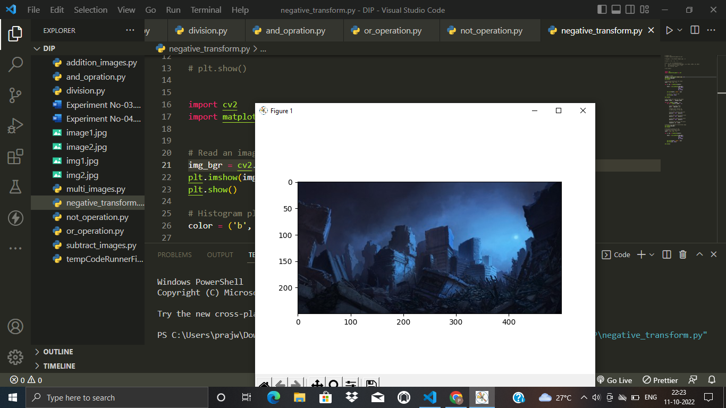**Output:**

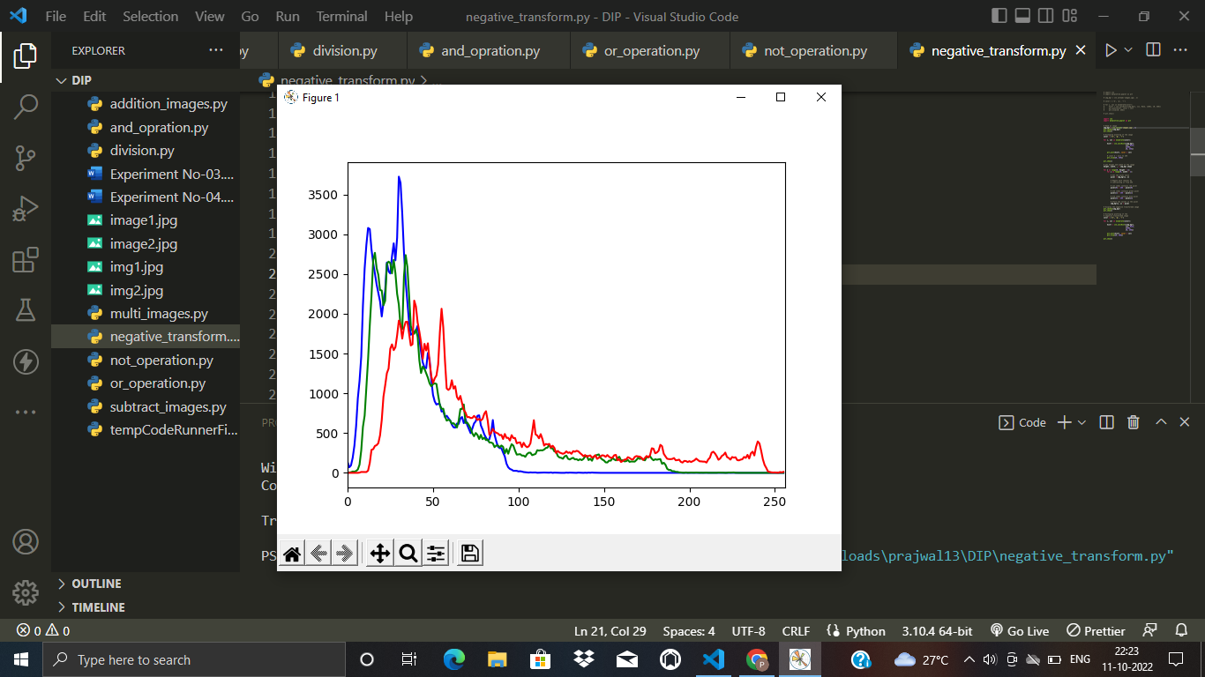

**b) Log Transform**

**Code:**

import cv2

import numpy as np

import matplotlib.pyplot as plt

import math

# Read an image

image = cv2.imread('image1.png')

# Apply log transformation method

c = 255 / np.log(1 + np.max(image))

log_image = c * (np.log(image + 1))

# Specify the data type so that

# float value will be converted to int

log_image = np.array(log_image, *dtype* = np.uint8)

# Display both images

plt.imshow(image)

plt.show()

plt.imshow(log_image)

plt.show()

**Input:**

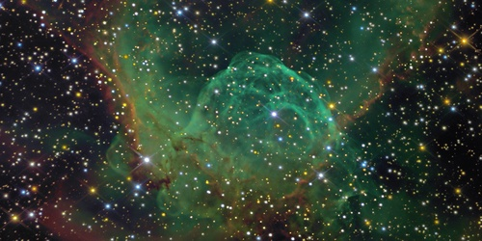

**Output:**

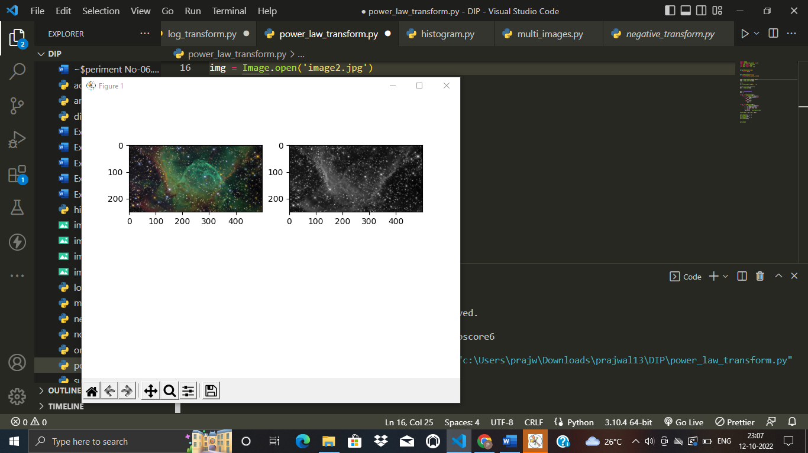

1. **Power Transform**

**Code:**

import numpy

import matplotlib.pyplot as plt

from copy import deepcopy

from PIL import Image

from math import cos, sin

*def* getGrayColor(*rgb*):

    return *rgb*[0]

*def* setGrayColor(*color*):

    return [*color*, *color*, *color*]

img = Image.open('image1.jpg')

img = numpy.asarray(img)

c = 1

y = float(input("input y :"))

# copy list not reference

pwl = deepcopy(img)

min = 99999999999999

max = 0

for i in range(len(img)):

    for j in range(len(img[i])):

        s = (c*img[i][j][0])**y

        if(s > max):

            max = s

        if(s < min):

            min = s

for i in range(len(img)):

    for j in range(len(img[i])):

        s = (c*img[i][j][0])**y

        s = (s-min)/(max-min)

        s = s*254

        pwl[i][j] = setGrayColor(s)

print('min:',min,'max:',max)

plt.subplot(2, 2, 1)

plt.imshow(img)

plt.subplot(2, 2, 2)

plt.imshow(pwl)

plt.show()

**Input & Output:**

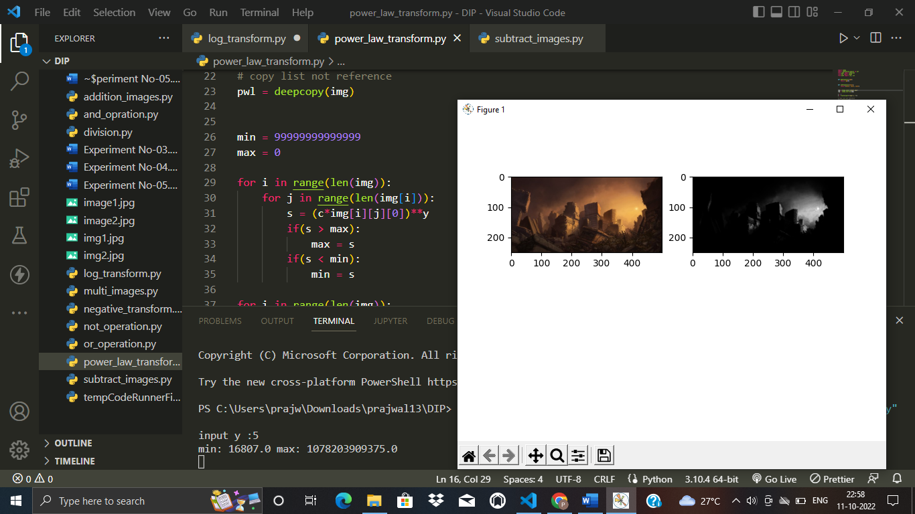

input y :5

min: 16807.0 max: 1078203909375.0